**Content**

1. .gitlab-ci.yml 2

1. Artifacts, what are artifacts? 3

1. Overview of Gitlab CI

It is free and open source software which is added in both GitLab Community Edition and the proprietary GitLab Enterprise Edition.

GitLab CI (Continuous Integration) service is a part of GitLab that build and test the software whenever developer pushes code to application. GitLab CD (Continuous Deployment) is a software service that places the changes of every code in the production which results in every day deployment of production.

* 1. .gitlab-ci.yml

This is a convention, gitlab will automatically recognize the file.

Once you’ve added your .gitlab-ci.yml configuration file to your repository, GitLab will detect it and run your scripts with the tool called **GitLab Runner**, which works similarly to your terminal.

The scripts are grouped into jobs, and together they compose a pipeline. A minimalist example of .gitlab-ci.yml file could contain:

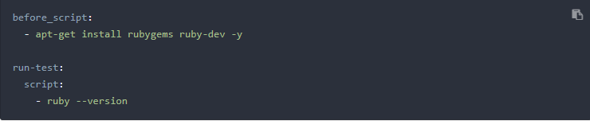

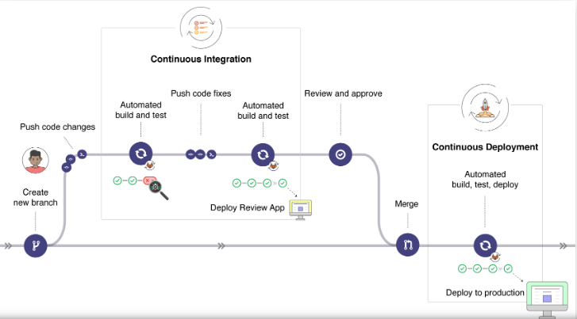

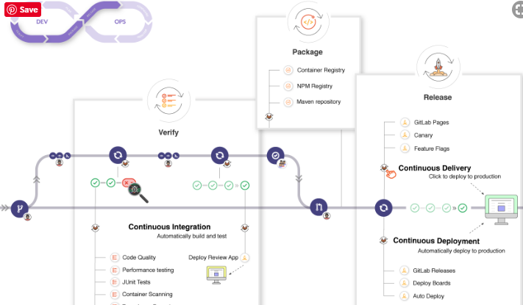

* 1. Artifacts, what are artifacts?
  2. GitLab CI Runner
  3. GitLab’s Docker Registry

Setting up your own Docker registry lets you push and pull images from your own private server, increasing security and reducing the dependencies your workflow has on outside services.